## Structure

Structure in c is a user-defined data type that enables us to store the collection of different data types. Each element of a structure is called a member. Structures ca; simulate the use of classes and templates as it can store various information

The **,struct** keyword is used to define the structure. Let's see the syntax to define the structure in c.

1. **struct** structure_name
2. {
3. data_type member1;
4. data_type member2;
5. .
6. .
7. data_type memeberN;
8. };

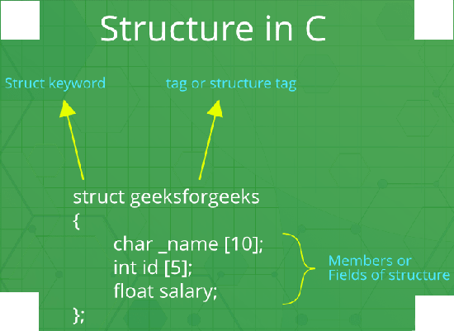

## Declaring structure variable

We can declare a variable for the structure so that we can access the member of the structure easily. There are two ways to declare structure variable:

1. By struct keyword within main() function
2. By declaring a variable at the time of defining the structure.

**1st way:**

Let's see the example to declare the structure variable by struct keyword. It should be declared within the main function.

1. **struct** employee
2. {   **int** id;
3. **char** name[50];
4. **float** salary;
5. };

Now write given code inside the main() function.

1. **struct** employee e1, e2;

The variables e1 and e2 can be used to access the values stored in the structure. Here, e1 and e2 can be treated in the same way as the objects in C++ and Java.

**2nd way:**

Let's see another way to declare variable at the time of defining the structure.

1. **struct** employee
2. {   **int** id;
3. **char** name[50];
4. **float** salary;
5. }e1,e2;

#### Which approach is good

If number of variables are not fixed, use the 1st approach. It provides you the flexibility to declare the structure variable many times.

If no. of variables are fixed, use 2nd approach. It saves your code to declare a variable in main() function.

## Accessing members of the structure

There are two ways to access structure members:

1. By . (member or dot operator)
2. By -> (structure pointer operator)